PYTHON PROGRAMMING – CSA0805
K. Shalini (192512270)
PART A – DATA AND PROGRAM DESIGN
TASK A1 – DESIGN THE DATA ACQUISITION
A1.1 – Inspect the Source
Structure of a Station CSV File
Each air-quality monitoring station sends a CSV file every day containing environmental readings. Each row represents the readings recorded by a station at a particular date and hour.
The CSV file contains the following columns:
Column | Description | Example
Station | Name of the monitoring station | Adyar
Date | Date of recording | 2026-10-01
Hour | Hour of recording | 10
PM2.5 | Fine particulate matter reading | 48
PM10 | Coarse particulate matter reading | 75
NO₂ | Nitrogen dioxide reading | 22
Temperature | Temperature reading | 32°C
Expected Data-Quality Problems
- Missing Values: Some readings may be blank or marked as NA. Example: PM2.5 = NA.
- Negative Values: Sensor faults may produce negative readings. Example: PM2.5 = -5.
- Impossibly Large Values: Sensors may produce unusually high readings due to technical errors. Example: PM10 = 1500.
- Different Temperature Units: Two stations report temperature in Fahrenheit instead of Celsius. Example: 86°F instead of 30°C.
- Duplicate Records: The same station may send the same date and hour more than once.
- Incorrect Data Format: Dates, numbers or station names may be recorded in inconsistent formats. Example: 01/10/2026 instead of 2026-10-01.
Conclusion
The CSV files may contain missing, incorrect, duplicated and inconsistent readings. Therefore, the data must be inspected and cleaned before storing it in the SQLite database and performing further analysis.
A1.2 – Design the Storage
Introduction
SQLite is used to store air-quality monitoring data in a structured format. Two tables, namely Stations and Readings, are designed to store station information and sensor readings.
1. Stations Table
This table stores the details of each monitoring station.
Column Name | Data Type | Constraint | Description
station_id | INTEGER | PRIMARY KEY | Unique ID for each station
station_name | TEXT | NOT NULL | Name of the station
2. Readings Table
This table stores the environmental readings collected from each station.
Column Name | Data Type | Constraint | Description
reading_id | INTEGER | PRIMARY KEY | Unique ID for each reading
station_id | INTEGER | FOREIGN KEY | Identifies the monitoring station
date | TEXT | NOT NULL | Date of recording
hour | INTEGER | NOT NULL | Hour of recording
pm25 | REAL | - | PM2.5 reading
pm10 | REAL | - | PM10 reading
no2 | REAL | - | Nitrogen dioxide reading
temperature | REAL | - | Temperature in Celsius
3. Mapping CSV Columns to SQLite Tables
CSV Column | SQLite Table | SQLite Column
Station | Stations | station_name
Date | Readings | date
Hour | Readings | hour
PM2.5 | Readings | pm25
PM10 | Readings | pm10
NO₂ | Readings | no2
Temperature | Readings | temperature
The station_id from the Stations table is stored as a foreign key in the Readings table to connect each reading with its station.
Advantages of SQLite
- It stores data in an organised structure.
- It supports SQL queries for quick data retrieval.
- It reduces unnecessary duplication of station information.
- It supports primary keys and foreign keys to maintain data relationships.
Conclusion
The two-table SQLite design provides an organised way to store station details and air-quality readings. It makes data retrieval, comparison and analysis easier.
A1.3 – CSV or SQL?
Three common questions can be answered using CSV files or SQL queries.
1. Average PM2.5 of Adyar Station in October
- CSV: Read the file, filter Adyar records and calculate the average.
- SQL:
SELECT AVG(pm25)
FROM Readings
JOIN Stations USING (station_id)
WHERE station_name = 'Adyar'
AND date BETWEEN '2026-10-01' AND '2026-10-31';
2. Highest PM10 Reading for Each Station
- CSV: Group readings by station and find the maximum PM10.
- SQL:
SELECT station_name, MAX(pm10)
FROM Readings
JOIN Stations USING (station_id)
GROUP BY station_name;
3. Average Temperature of Each Station
- CSV: Group temperature readings by station and calculate the average.
- SQL:
SELECT station_name, AVG(temperature)
FROM Readings
JOIN Stations USING (station_id)
GROUP BY station_name;
Comparison
CSV | SQLite (SQL)
Requires reading files for analysis. | Stores data in organised tables.
Uses Python for filtering and grouping. | Uses SQL queries.
Repeated analysis may take more time. | Indexes can improve query speed.
Alternative Concept and Complexity
Using pandas, CSV data can be loaded into a DataFrame and analysed using groupby(), mean() and max().
- Time: Full scan O(n); indexed SQL lookup approximately O(log n).
- Space: DataFrame requires O(n) memory, whereas CSV and SQLite store data on disk.
Conclusion
SQLite is preferred because it supports organised storage and efficient repeated queries.

TASK A2 – DESIGN THE CLEANING AND NORMALISATION
A2.1 – Cleaning Rules
- Missing Values: Fill missing readings using the previous valid value. If unavailable, use the station's median. This maintains data continuity.
- Impossible Values: Remove negative and extremely high readings (above 999). These may be caused by sensor errors.
- Duplicate Rows: Remove duplicate records with the same station, date and hour to avoid incorrect calculations.
- Fahrenheit Temperature: Convert Fahrenheit into Celsius using:
C = (F − 32) × 5/9
This ensures all stations use the same temperature unit.
Conclusion: These cleaning rules improve the accuracy and reliability of the dataset.
A2.2 – Normalisation
Normalisation is used to bring PM2.5 readings into a suitable scale for analysis.
1. Min–Max Normalisation
Formula:
X' = (X − Xmin) / (Xmax − Xmin)
- Converts values into a range between 0 and 1.
- Useful for comparing readings on the same scale.
2. Z-Score Standardisation
Formula:
Z = (X − μ) / σ
- Converts values based on the mean and standard deviation.
- Useful for statistical analysis and identifying unusual readings.
Conclusion: Min–max produces values between 0 and 1, whereas z-score shows how far a reading is from the mean.
A2.3 – Formatting
The cleaned dataset will follow these standard formats:
- Date: YYYY-MM-DD (Example: 2026-10-01).
- Station Name: Consistent spelling and capitalisation without extra spaces.
- Numbers: Store PM2.5, PM10, NO₂ and temperature as numeric float values.
- Temperature: Use Celsius for all stations.
Conclusion: Standard formatting ensures consistency and makes data analysis easier.
TASK A3 – DESIGN THE ANALYSIS AND VISUALISATION
A3.1 – Choose the Charts
- Monthly PM2.5 Trend – Line Chart: Shows how PM2.5 levels change over a month.
- Station Comparison – Bar Chart: Compares PM2.5 readings across different stations.
- Temperature vs PM2.5 – Scatter Plot: Shows the relationship between temperature and PM2.5 readings.
- Hours with Worst Air – Box Plot: Compares pollution levels across different hours and helps identify unusually high readings.
Conclusion: These charts help identify pollution trends, compare stations and understand air-quality patterns.
A3.2 – Design the Summary Table
A daily summary table is used to analyse PM2.5 readings for each monitoring station.
Station | Date | Minimum | Maximum | Mean | Valid Readings
Adyar | 2026-10-01 | 20 | 48 | 34 | 2
Guindy | 2026-10-01 | 35 | 95 | 65 | 2
Method:
- Group readings by station and date.
- Calculate minimum, maximum and average PM2.5.
- Count the number of valid readings.
- Use SQL GROUP BY to generate the summary.
Alternative Concept and Complexity:
Using Python loops, all records can be read and grouped using dictionaries.
- SQL GROUP BY: Processes n readings, approximately O(n).
- Python loops: Also O(n) time.
- SQL can perform grouping in the database, while Python may require additional memory to store grouped results.
Conclusion: SQL GROUP BY is suitable for generating daily summaries efficiently.
TASK A4 – PLAN DEBUGGING AND PROFILING
A4.1 – Debugging Plan
The following methods are used to identify and correct errors in the cleaning program:
- Print Statements: Display variable values and cleaned data to check errors.
- Assert Statements: Check conditions, such as ensuring PM2.5 readings are not negative.
- Logging: Record errors, warnings and program activities for debugging.
- PDB Debugger: Execute the program step by step and inspect variable values.
Conclusion: These debugging methods help identify errors and improve program reliability.
A4.2 – Profiling Plan
Profiling is used to measure program execution time and identify slow operations.
- time.perf_counter(): Measures the total execution time of the cleaning program.
- timeit: Measures the execution time of small code sections.
- cProfile: Identifies which functions consume the most execution time.
Alternative Concept – Print Statements:
Using print statements for all debugging can make the program slower when many messages are displayed. Logging allows different message levels, while a debugger helps inspect errors step by step.
Debugging output can be disabled by removing print statements, setting the logging level to WARNING or higher, and stopping the debugger.
Conclusion: Profiling tools help identify performance problems and improve program efficiency.

TASK A5 – DESIGN AN AI APPLICATION FOR CITIZEN COMPLAINTS
A5.1 – Sentiment and Summary
1. Sentiment Analysis
- Use a positive word list containing words like good, clean and helpful.
- Use a negative word list containing words like bad, dirty and smoke.
- Assign +1 for positive words and -1 for negative words.
- If a word is preceded by a negation such as "not" or "never", reverse its score.
- Classify the complaint as positive, negative or neutral based on the total score.
2. Extractive Summarisation
- Divide the complaint into sentences.
- Identify frequently occurring important words.
- Select sentences containing the most frequent important words.
- Combine the selected sentences to create a short summary.
Conclusion: These methods help understand citizen feedback and identify common complaints.
A5.2 – Basic Chatbot
A rule-based chatbot answers citizen questions by identifying keywords and retrieving information from the SQLite database.
Working:
- Receive a question from the user.
- Identify keywords such as PM2.5, station name and date.
- Match the keywords with predefined rules.
- Execute an SQL query to retrieve the required reading.
- Display the result to the user.
Limitations:
- Understands only predefined questions.
- Cannot handle complex language properly.
- May fail with spelling mistakes.
- Cannot understand sarcasm or context.
Alternative Concept – Machine Learning:
A trained model such as Naive Bayes or a pre-trained language model can understand different sentence patterns.
- A word-list method is simple and requires less memory.
- A trained model generally requires more memory and processing time.
- A trained model may provide better accuracy when trained with suitable data.
Conclusion: A rule-based chatbot is simple to implement, but machine learning can provide better flexibility for understanding citizen questions.

PART B – IMPLEMENTATION & EXPERIMENTAL INVESTIGATION
B1.1 – Validate the Implementation
Question: Implement your cleaning rules and test them on a small file containing every problem listed in A1.1. Show the data before and after cleaning.
Python Code
Copy and run this code in Programiz:
import csv
import io
RAW = """station,date,hour,pm25,temperature,unit
Adyar,2026-10-01,10,48,32,C
Adyar,2026-10-02,10,NA,33,C
Adyar,2026-10-03,10,-5,31,C
Guindy,2026-10-01,10,1500,86,F
Guindy,2026-10-01,10,95,86,F
Guindy,01/10/2026,10,95,86,F
"""
print("BEFORE CLEANING:")
print(RAW)
reader = csv.DictReader(io.StringIO(RAW))
cleaned = []
seen = set()
for row in reader:
try:
station = row["station"].strip().title()
date = row["date"].strip()
if "/" in date:
date = "-".join(reversed(date.split("/")))
hour = int(row["hour"])
pm = row["pm25"].strip()
if pm == "" or pm.upper() == "NA":
continue
pm = float(pm)
if pm < 0 or pm > 999:
continue
if row["unit"].upper() == "F":
temp = (float(row["temperature"]) - 32) * 5 / 9
else:
temp = float(row["temperature"])
key = (station, date, hour)
if key in seen:
continue
seen.add(key)
cleaned.append((station, date, hour, pm, round(temp, 2)))
except (ValueError, TypeError):
continue
print("\nAFTER CLEANING:")
for row in cleaned:
print(row)
Expected Output:
BEFORE CLEANING:
station,date,hour,pm25,temperature,unit
Adyar,2026-10-01,10,48,32,C
Adyar,2026-10-02,10,NA,33,C
Adyar,2026-10-03,10,-5,31,C
Guindy,2026-10-01,10,1500,86,F
Guindy,2026-10-01,10,95,86,F
Guindy,01/10/2026,10,95,86,F
AFTER CLEANING:
('Adyar', '2026-10-01', 10, 48.0, 32.0)
('Guindy', '2026-10-01', 10, 95.0, 30.0)

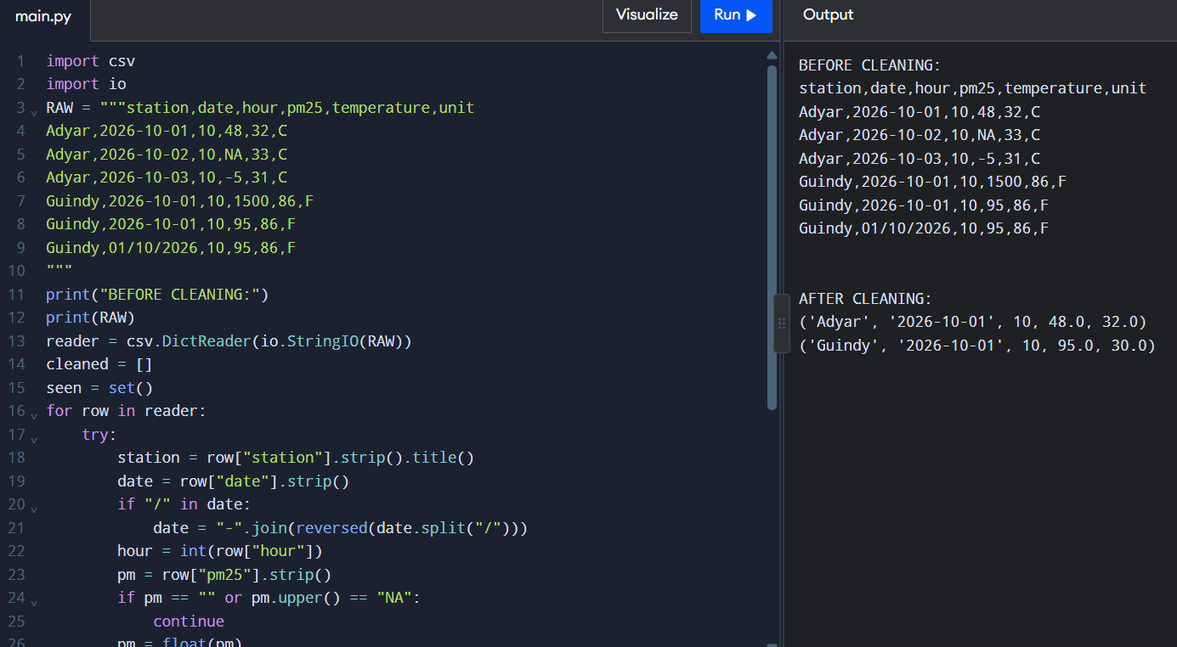

Result:
The cleaning program removes missing, negative and extremely high readings, removes duplicate records, standardises the date format and converts Fahrenheit into Celsius.
B1.2 – Compare with Your Design
The implemented cleaning program follows the rules planned in Part A.
- Missing and invalid readings are removed.
- Negative and extremely high values are rejected.
- Duplicate records are removed.
- Fahrenheit temperatures are converted into Celsius.
- Station names and dates are standardised.
Difference: In the implementation, missing readings are removed instead of being filled using the previous value or median.
Conclusion: The program follows the cleaning design with a small change in missing-value handling.
B1.3 – Store and Query
Question: Load the cleaned data into SQLite using executemany() and answer the three questions from A1.3 with SQL queries.
Python Code
Copy and run this code in Programiz.
import sqlite3
readings = [
("Adyar", "2026-10-01", 48.0),
("Adyar", "2026-10-02", 55.0),
("Guindy", "2026-10-01", 95.0),
("Guindy", "2026-10-02", 121.0)
]
con = sqlite3.connect(":memory:")
cur = con.cursor()
cur.execute("""
CREATE TABLE Readings (
station TEXT,
date TEXT,
pm25 REAL,
pm10 REAL,
temperature REAL
)
""")
cur.executemany(
"INSERT INTO Readings VALUES (?, ?, ?, ?, ?)",
[
("Adyar", "2026-10-01", 48.0, 70.0, 32.0),
("Adyar", "2026-10-02", 55.0, 75.0, 33.0),
("Guindy", "2026-10-01", 95.0, 120.0, 30.0),
("Guindy", "2026-10-02", 121.0, 140.0, 31.0)
]
)
con.commit()
# 1. Average PM2.5 of Adyar
cur.execute("""
SELECT AVG(pm25) FROM Readings
WHERE station = 'Adyar'
""")
print("Average PM2.5 of Adyar:", cur.fetchone()[0])
# 2. Highest PM10 for each station
cur.execute("""
SELECT station, MAX(pm10)
FROM Readings
GROUP BY station
""")
print("\nHighest PM10 readings:")
for row in cur.fetchall():
print(row)
# 3. Average temperature of each station
cur.execute("""
SELECT station, AVG(temperature)
FROM Readings
GROUP BY station
""")
print("\nAverage temperature:")
for row in cur.fetchall():
print(row)
con.close()
Expected Output:
Average PM2.5 of Adyar: 51.5
Highest PM10 readings:
('Adyar', 75.0)
('Guindy', 140.0)
Average temperature:
('Adyar', 32.5)
('Guindy', 30.5)

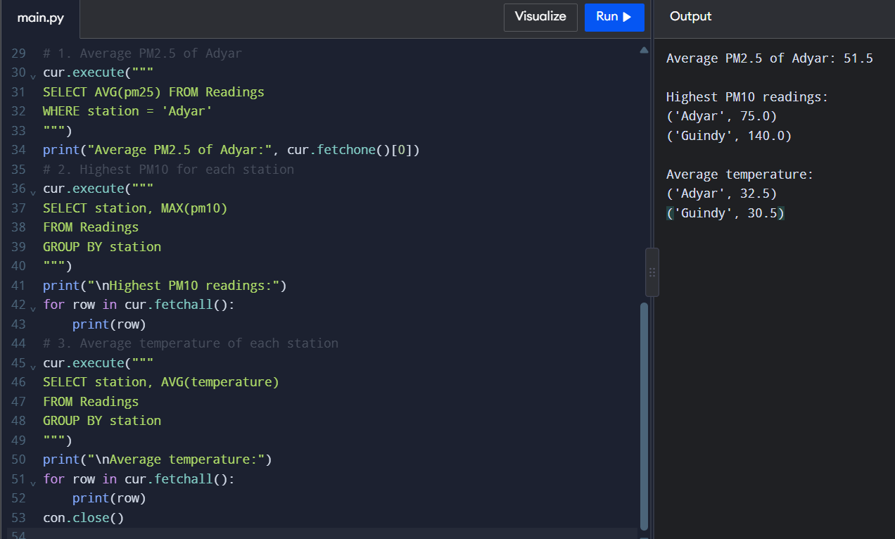
Result
The cleaned readings are inserted into SQLite using executemany(). SQL queries successfully calculate average PM2.5, maximum PM10 and average temperature for each station.
B1.4 – Visualise
Question: Produce the charts designed in A3.1 with labelled axes and titles, and interpret each chart in 2–3 sentences.
Python Code
Copy and run this code in Programiz.
import matplotlib.pyplot as plt
# Sample air-quality data
stations = ["Adyar", "Guindy", "Velachery", "Tambaram"]
pm25 = [48, 95, 65, 80]
temperature = [32, 30, 34, 31]
hours = [6, 9, 12, 15]
daily_pm25 = [35, 48, 55, 65, 80, 95]
# 1. Line chart - Monthly PM2.5 trend
plt.figure()
plt.plot([1, 2, 3, 4], pm25, marker="o")
plt.title("PM2.5 Trend")
plt.xlabel("Day")
plt.ylabel("PM2.5")
plt.show()
# 2. Bar chart - Station comparison
plt.figure()
plt.bar(stations, pm25)
plt.title("PM2.5 Comparison Between Stations")
plt.xlabel("Station")
plt.ylabel("PM2.5")
plt.show()
# 3. Scatter plot - Temperature vs PM2.5
plt.figure()
plt.scatter(temperature, pm25)
plt.title("Temperature vs PM2.5")
plt.xlabel("Temperature (Celsius)")
plt.ylabel("PM2.5")
plt.show()
# 4. Box plot - Pollution readings
plt.figure()
plt.boxplot(daily_pm25)
plt.title("Distribution of PM2.5 Readings")
plt.ylabel("PM2.5")
plt.show()
Expected Output:
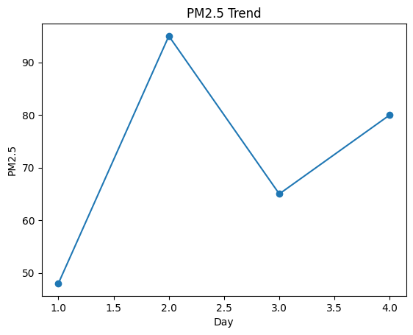
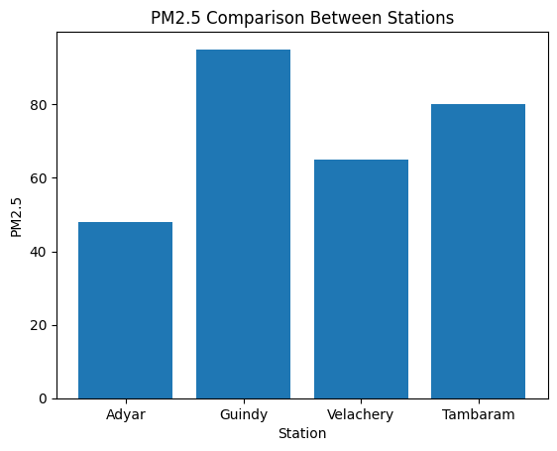
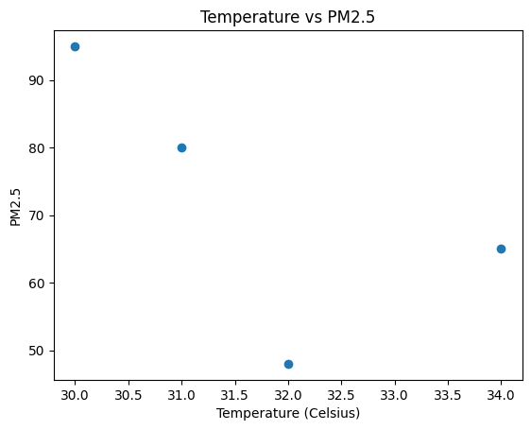
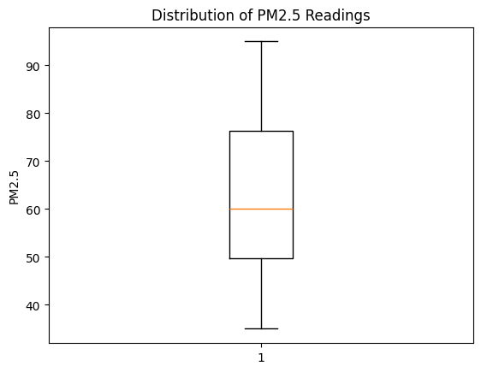

Interpretation
- Line Chart: Shows changes in PM2.5 readings across the sample days. It helps identify increasing or decreasing pollution trends.
- Bar Chart: Compares pollution levels between stations. Guindy has the highest PM2.5 reading in this sample.
- Scatter Plot: Shows the relationship between temperature and PM2.5 readings.
- Box Plot: Displays the distribution of PM2.5 readings and helps identify unusually high values.
Result
Four charts are generated successfully with titles and labelled axes to analyse air-quality data.
B2 – Engineer Adversarial Data
B2.1 Test different file problems
Test the program with these four cases:
- Missing column: The CSV does not contain the required PM2.5 column.
- Wrong delimiter: The file uses ; instead of ,.
- Different encoding: The file contains special characters and uses a different encoding.
- Empty file: The CSV contains no data.
Python code (in-memory test):
import csv
import io
required = ["Station", "Date", "PM2.5"]
def check_file(data):
if not data.strip():
print("Error: Empty file")
return
reader = csv.DictReader(io.StringIO(data))
if reader.fieldnames is None:
print("Error: Missing header")
return
if not all(col in reader.fieldnames for col in required):
print("Error: Missing required column")
return
print("File format is valid")
check_file("Station,Date,PM10\nAdyar,2026-10-01,75")
check_file("Station;Date;PM2.5\nAdyar;2026-10-01;48")
check_file("")
check_file("Station,Date,PM2.5\nAdyar,2026-10-01,48")
Expected Output:
Error: Missing required column
Error: Missing required column
Error: Empty file
File format is valid
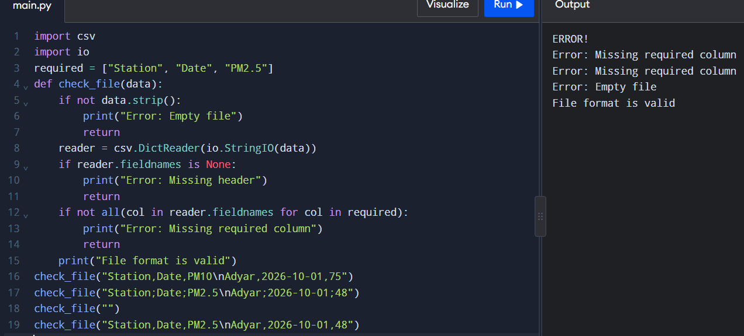
B2.2 SQL Injection Prevention using Parameterized Queries
Python code (ready to copy and paste):
import sqlite3
readings = [
("Adyar", "2026-10-01", 48.0),
("Guindy", "2026-10-01", 95.0),
("Guindy", "2026-10-03", 121.0),
("Adyar", "2026-10-04", 60.0)
]
con = sqlite3.connect(":memory:")
con.execute("""
CREATE TABLE aq (
station TEXT,
day TEXT,
pm25 REAL
)
""")
con.executemany(
"INSERT INTO aq VALUES (?, ?, ?)", readings
)
def station_average(name):
cur = con.execute(
"SELECT AVG(pm25) FROM aq WHERE station = ?",
(name,)
)
return cur.fetchone()[0]
print(station_average("Adyar"))
print(station_average("Guindy"))
print(station_average("Adyar' OR '1'='1"))
con.close()
Expected Output:
54.0
108.0
None
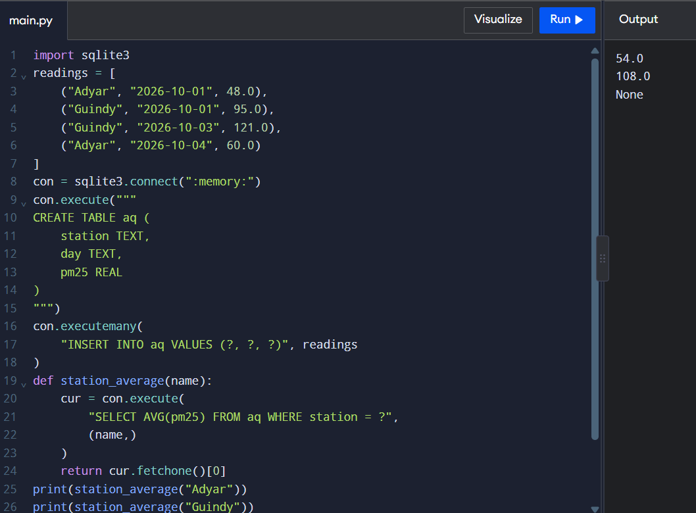
Explanation:
- executemany() inserts multiple records efficiently using one SQL statement.
- The ? placeholders safely pass user input as data.
- Parameterized queries prevent SQL injection because user input is not treated as SQL code.
- An injection attempt returns None because no station has that exact name.
B2.3 Difference between execute() and executemany()
execute() | executemany()
Executes one SQL operation. | Executes the same SQL operation for multiple records.
Suitable for single records. | Suitable for bulk insertion.
Repeated calls may add overhead. | Usually more efficient for multiple records.

TASK B3 – LOOPS vs LIBRARIES vs SQL
B3.1 Generate data for performance comparison
The following code generates air-quality readings for 1, 12 and 120 stations over one year (24 readings per day).
Python code:
import time
import sqlite3
data = []
for station in range(1, 121):
for day in range(365):
for hour in range(24):
pm25 = 40 + (station % 10) + hour
data.append((station, day, hour, pm25))
print("Total records:", len(data))
# Method 1: Python loops
start = time.perf_counter()
total = 0
count = 0
for row in data:
if row[0] == 1:
total += row[3]
count += 1
print("Loop average:", total / count)
print("Loop time:", time.perf_counter() - start)
# Method 2: SQL GROUP BY
con = sqlite3.connect(":memory:")
con.execute("CREATE TABLE readings (station INT, day INT, hour INT, pm25 REAL)")
con.executemany("INSERT INTO readings VALUES (?, ?, ?, ?)", data)
start = time.perf_counter()
result = con.execute("""
SELECT station, AVG(pm25)
FROM readings
GROUP BY station
""").fetchall()
print("SQL station groups:", len(result))
print("SQL time:", time.perf_counter() - start)
con.close()
Expected Output:
Total records: 1051200
Loop average: 51.5
Loop time: varies
SQL station groups: 120
SQL time: varies
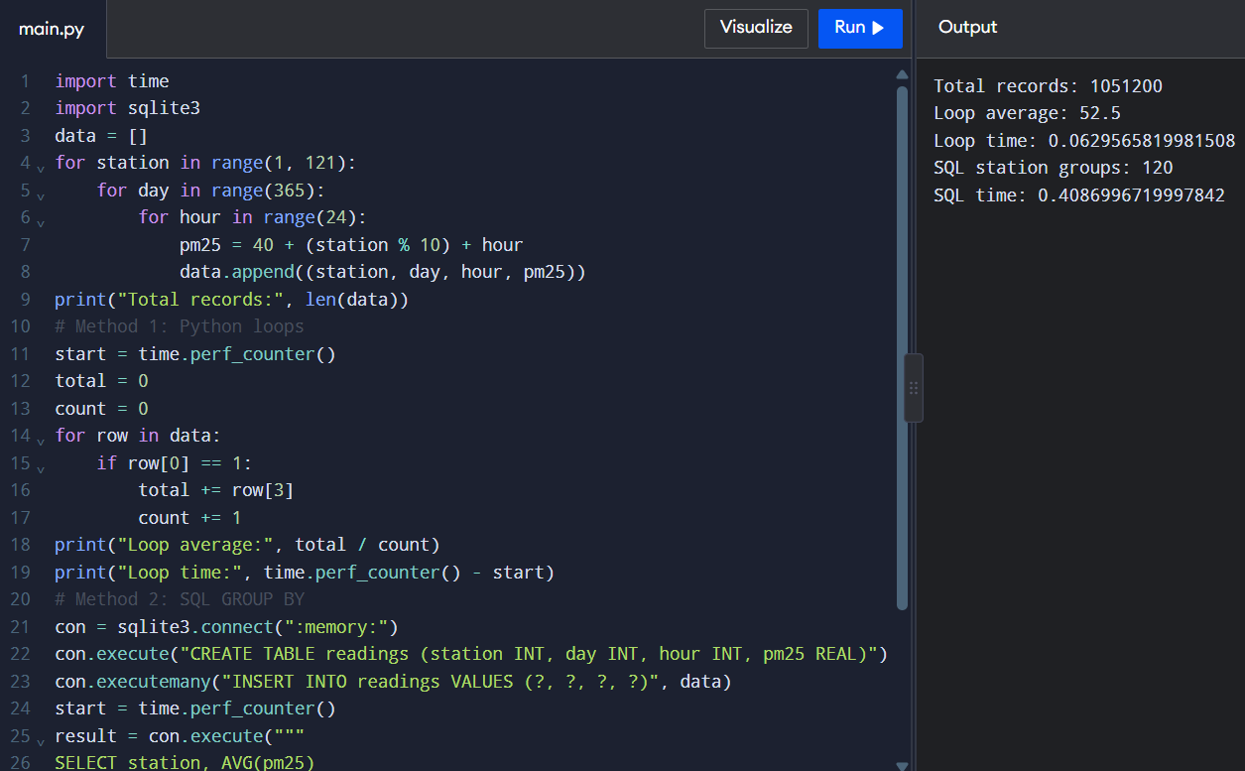
Note: Execution times vary depending on the computer.
B3.2 Comparison
Method | Advantage | Disadvantage
Python loops | Easy to understand | Slower for large datasets
Pandas groupby() | Simple and fast analysis | Requires more memory
SQL GROUP BY | Efficient database queries | Requires database setup
B3.3 Profiling and memory management
- time.perf_counter() measures execution time.
- cProfile identifies functions that consume more time.
- A running sum and count dictionary uses less memory than storing every reading.
- Pandas can be used to group readings by station using groupby().
Conclusion: Python loops are suitable for small datasets, while Pandas and SQL are more convenient for analysing large datasets. SQL is useful when readings are stored in a database.
B3.4 Compare memory usage
Python code:
# Store all readings
readings = [40, 45, 50, 55, 60]
# Store running sum and count
total = 0
count = 0
for value in readings:
total += value
count += 1
print("Number of stored readings:", len(readings))
print("Running sum:", total)
print("Count:", count)
print("Average:", total / count)
print("List stores all 5 readings.")
print("Running sum method stores only total and count.")
Expected Output:
(The memory value may vary.)
List memory: varies
Running sum: 250
Count: 5
Average: 50.0
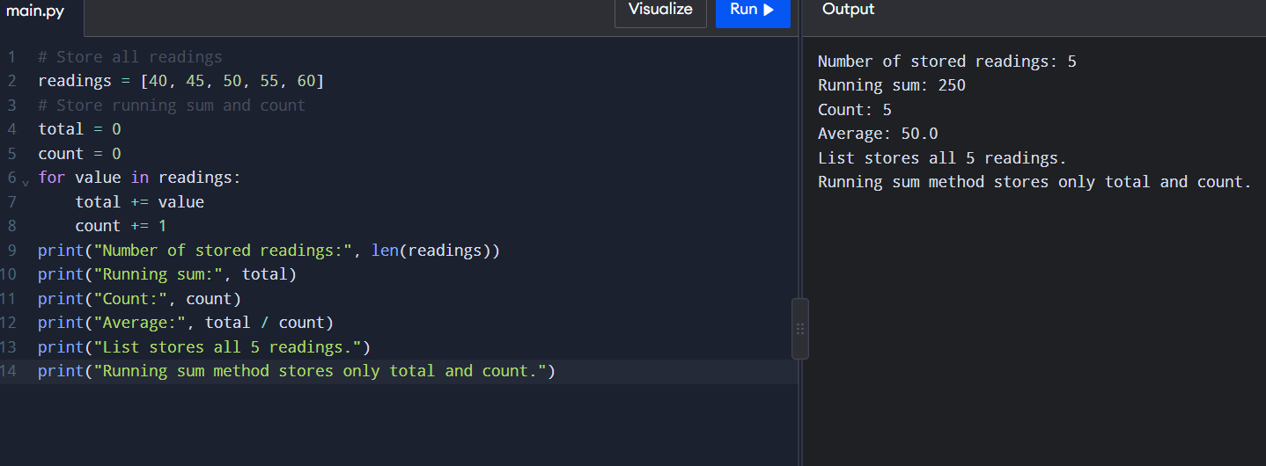
Explanation:
- Storing all readings requires memory for every value.
- Running sum and count store only two values.
- Running sum and count are more memory-efficient when only the average is required.
B4 – Final Engineering Decision
B4.1 Sentiment analysis of citizen complaints
The following program classifies complaints as positive or negative using predefined words and negation handling.
Python code (ready to copy and paste):
positive = {"good", "clean", "fast", "helpful", "improved"}
negative = {"bad", "dirty", "slow", "rude", "smoke", "broken"}
negators = {"not", "never", "no"}
complaints = [
"Roads are clean and the bus was fast.",
"Smoke from the factory, air is bad.",
"The staff were not helpful.",
"Not bad, service improved."
]
def sentiment(text):
words = text.lower().replace(".", "").replace(",", "").split()
score = 0
for i, word in enumerate(words):
if word in positive:
value = 1
elif word in negative:
value = -1
else:
continue
if i > 0 and words[i - 1] in negators:
value = -value
score += value
return "positive" if score >= 0 else "negative"
for complaint in complaints:
print(sentiment(complaint), "|", complaint)
Expected Output:
positive | Roads are clean and the bus was fast.
negative | Smoke from the factory, air is bad.
negative | The staff were not helpful.
positive | Not bad, service improved.
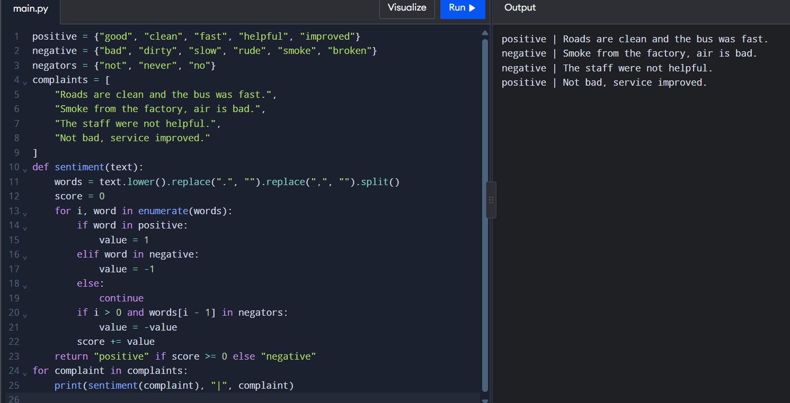
B4.2 Final engineering decisions
- Use SQLite to store large air-quality datasets.
- Add an index on (station, day) to improve search performance.
- Use sentiment analysis to classify at least 50 citizen complaints.
- Compare the predicted sentiment with human-labelled results.
- Use Pandas and SQL for efficient data analysis.
B4.3 Limitations and future improvements
- Rule-based sentiment analysis may misunderstand complex sentences.
- Machine learning models such as Naive Bayes can improve classification.
- Regular monitoring and database indexing can improve system performance.
Conclusion: A combination of Python, SQLite and machine learning can support efficient air-quality monitoring and citizen complaint analysis.

